**What is a Data Warehouse?**

* **Data Warehouse**: A special place to store large amounts of data from different sources, meant to help people make decisions.
* **Main Features**:
  + **Subject-oriented**: Organizes data by subjects (like customers or sales).
  + **Integrated**: Combines data from different places into one format.
  + **Time-variant**: Stores data over a long time, showing trends and changes.
  + **Non-volatile**: Data is not changed once stored; it’s a historical record.
* **Decision Support System (DSS)**: Helps businesses make quick decisions based on data.
  + DSS uses **structured data** (like numbers and facts) and **unstructured data** (like opinions or guesses that need interpretation). 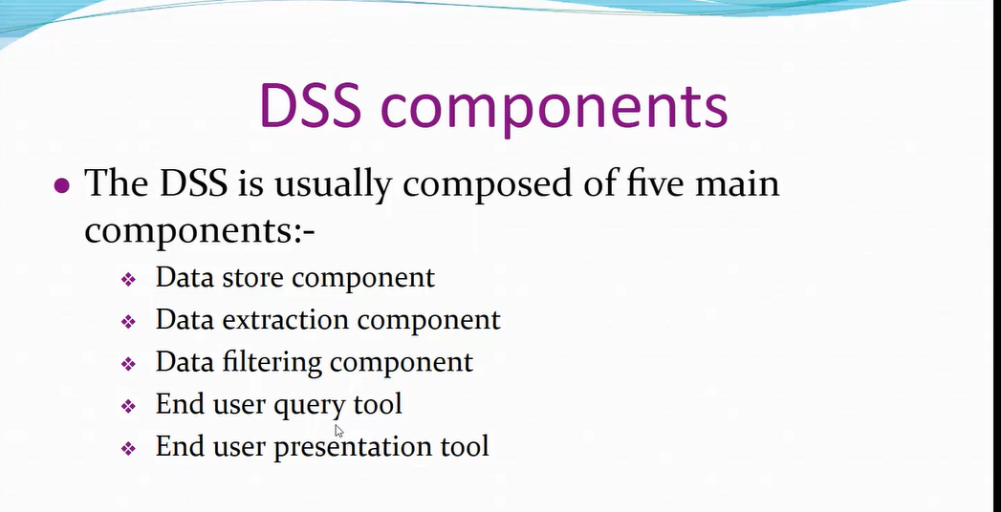

**OLTP vs. OLAP**

* **OLTP (Online Transaction Processing)**: Used for daily operations like bank transactions; it’s fast and efficient for simple tasks. 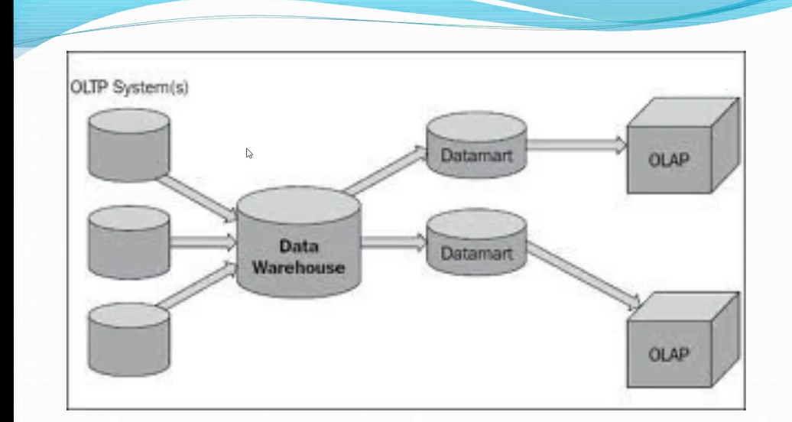
* **They are simple efficient**.They maintain data integrity.
* **Disadv**: Require instant updates,query multiple tables even for simpler data analysis
* **OLAP (Online Analytical Processing)**: Used for analyzing data in detail. It allows people to look at data from different angles, like by month, product, or region.

**How a Data Warehouse Works**

* **ETL Process (Extract, Transform, Load)**:
  1. **Extract**: Data is taken from different sources.
  2. **Transform**: Data is cleaned and converted into a standard format.
  3. **Load**: Data is loaded into the data warehouse for storage.

**ETL based warehouse uses 1.staging,2,integration,3.Access layers(data marts)** 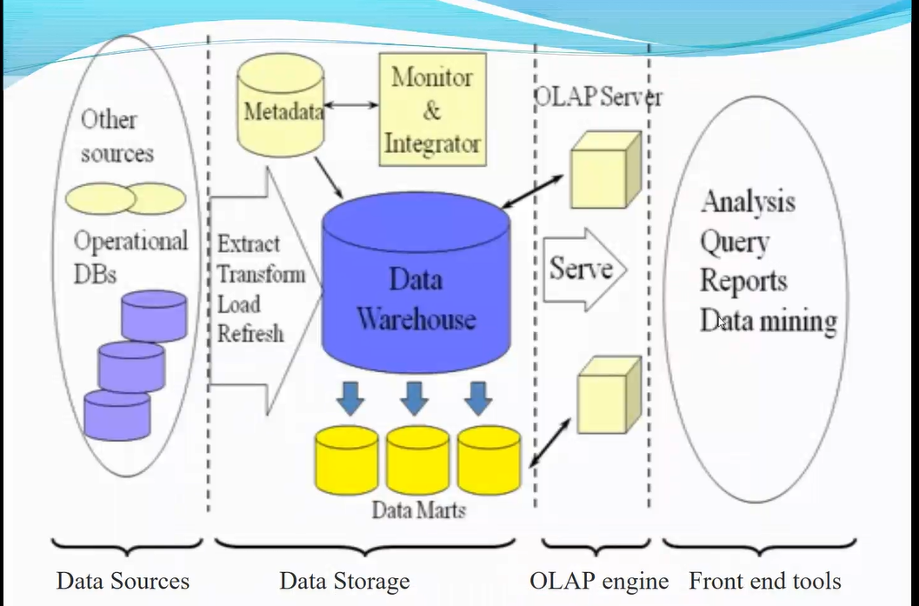

**Data Marts and OLAP Cubes**

* **Data Marts**: Small parts of the data warehouse focused on specific areas (like sales or marketing) so people can find information quickly. 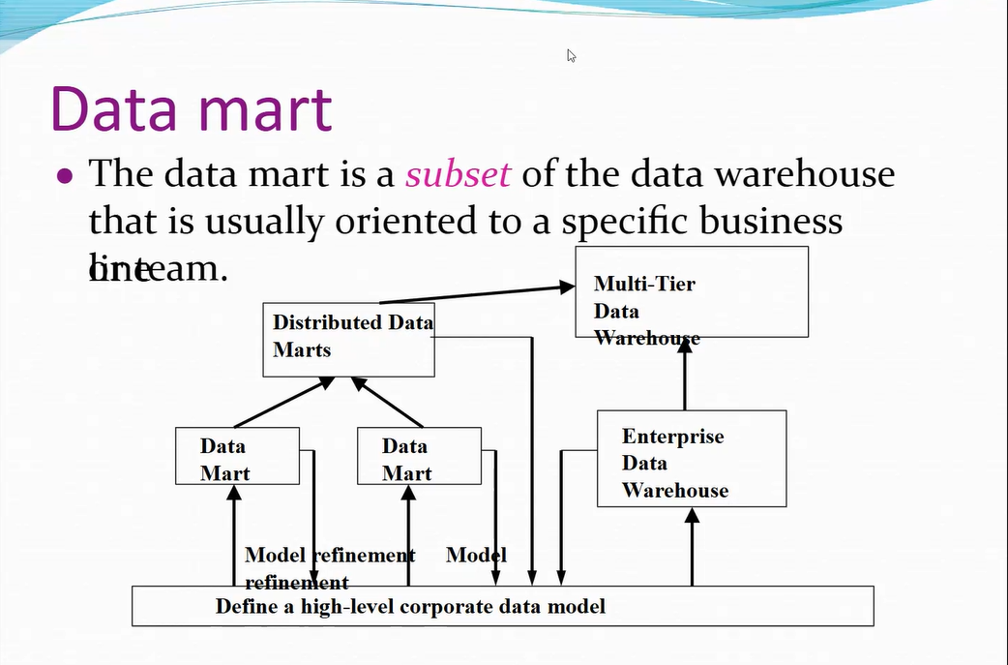
* **OLAP Cube**: A way to organize data in multiple dimensions (like time, product, and location) to answer questions easily.

**Types of OLAP**

1. **ROLAP (Relational OLAP)**: Uses a relational database and is flexible for complex questions, but might be slower.
2. **MOLAP (Multi-dimensional OLAP)**: Uses pre-built cubes, which makes it faster for repeated questions but requires setup.

**Uses of a Data Warehouse**

1. **Information Processing**: Basic reports and data tables, charts, etc.
2. **Analytical Processing**: Allows deeper analysis, like breaking data into parts and studying trends.
3. **Data Mining**: Finds hidden patterns to help predict future trends and make informed decisions.

Big data

